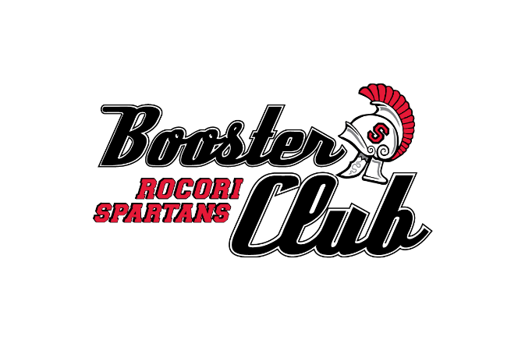

Become a 2020-2021 Member Today
We have officially launched our Rocori Spartans Booster Club membership drive for 2020-21. Rocori families, businesses and corporate partners all come together to help provide significant resources that allow our student athletes to consistently compete at a high level through conference, section and state competition. In recent years the Booster Club has provided over $80,000 annually to help our coaches and student athletes succeed. We fund uniforms on a rotating basis and provide other significant supplemental funding for regular and post season competition. Our primary mission is to fund extraordinary expenses that are central to sustaining our proud athletic tradition.
We invite you to become a member at one of our three membership levels: Red, Black or White. You may send your membership by mail (address below) or join online at rocoriboosterclub.com.
Thank You and Go Spartans!
Name(s): __________________________________________________________________________
Please list your name(s)as you prefer it on our membership recognition banner

Address: ____________________________________________________________________________

____________________________________________________________________________

Phone: ____________________________________________________________________________

Email: ____________________________________________________________________________

Membership Level:

Red Level ($100): ____ Black Level ($50): ____ White Level ($25): ____

Send check made out to Rocori Booster Club:
Rocori Spartans Booster Club
P.O. Box 343
Cold Spring, MN 56320

Or, join on-line at rocoriboosterclub.com

